**Working of Code**

**OBJECTIVE: Design and implement a simple inventory control system for a small video rental store.**

**Source Code**

**package** expr2_6019;

**import** java.util.*;

**class** video6019{

String title; //variable to store title

**boolean** check; //variable to check if video is available

**int** rating=0; //rating given by user

**void** getRating(**int** x) { //function to get rating

System.***out***.println("Rating accepted");

rating = x;

}

**void** rent() { //changes status of video

check = **false**;

}

**boolean** checked() { //checks if video is available

**return** check;

}

}

**class** videoStore6019{

**static** **int** *count*=0; //global scope in class

Scanner s1 = **new** Scanner(System.***in***); //scanner object for inputs

video6019 v[] = **new** video6019[10]; //video objects created

**void** listInventory() { // function to display video list

**if**(*count*==0) { // if list is empty

System.***out***.println("List is empty");

}

**else** {

System.***out***.println("VIDEOS");

**for**(**int** i=1; i<=*count*; i++) { // printing video list

System.***out***.print(i+": "+v[i].title);

System.***out***.print("\t\tRating: ");

**if**(v[i].rating==0) // if rating is not available

System.***out***.println("Not available");

**else**

System.***out***.println(v[i].rating+"/5");

}

}

}

**void** returnVideo() { //function to return video

**if**(*count*==0) //if no video to return

System.***out***.println("You have no video to return");

**else** {

System.***out***.println("Enter the video to return: ");

String def = s1.nextLine();

**int** present = 0;

**for**(**int** i=1; i<=*count*; i++) {

**if**(def.equalsIgnoreCase(v[i].title))

present = i;

}

**if**(present==0) // if video not in list

System.***out***.println("Video not found");

**else** {

**if**(v[present].check == **true**) // if video already returned

System.***out***.println("Video already in store");

**else** {

v[present].check = **true**;

System.***out***.println("Video returned");

}

}

}

}

**void** addVideo() {

**if**(*count*>10) //if inventory limit exceeded

System.***out***.println("Inventory limit exceeded");

**else** {

*count*++; //global scope of count

v[*count*] = **new** video6019(); //object constructor

System.***out***.println("Enter the title");

v[*count*].title = s1.nextLine();

v[*count*].check = **true**;

System.***out***.println("Video added successfully");

}

}

**void** checkOut() { //renting the video

System.***out***.println("Enter the name of video to rent");

String abc = s1.nextLine();

**int** present = 0;

**for**(**int** i=1; i<=*count*; i++) { //video search

**if**(abc.equalsIgnoreCase(v[i].title))

present = i;

}

**if**(present==0) // if video not found

System.***out***.println("Video not found");

**else** {

**if**(v[present].checked()) {

System.***out***.println("Video rented successfully");

v[present].rent();

}

**else**

System.***out***.println("Sorry, video not available");

}

}

**void** recieveRating() { //getting rating for video

**int** present = 0;

System.***out***.println("Enter the video name to enter rating: ");

String pr = s1.nextLine();

**for**(**int** i=1; i<=*count*; i++) { //video search

**if**(pr.equalsIgnoreCase(v[i].title))

present = i;

}

**if**(present==0)

System.***out***.println("Video not found"); //if video not found

**else** {

System.***out***.println("Enter the rating: ");

**int** x = s1.nextInt(); //getting rating from user

**if**(x==0)

System.***out***.println("Invalid rating");

**else** {

v[present].getRating(x);

}

}

}

}

**public** **class** VideoLauncher6019 {

**public** **static** **void** main(String[] args) {

Scanner s1 = **new** Scanner(System.***in***);

**int** choice1, choice2=1, choice3, choice4;

videoStore6019 store = **new** videoStore6019();

**while**(choice2 == 1) { // outer most loop

System.***out***.println("**************MENU**************"); //different login types

System.***out***.println("1: Login as Admin");

System.***out***.println("2: Login as User");

System.***out***.println("Enter the corresponding number as your choice: ");

choice1 = s1.nextInt();

**switch** (choice1){

**case** 1:{ // if logged in as admin

**int** cont1=1;

**while**(cont1==1) { // second loop

System.***out***.println("1: List inventory");

System.***out***.println("2: Add video");

System.***out***.println("Enter the corresponding number as your choice: ");

choice3 = s1.nextInt();

**switch**(choice3) {

**case** 1:{

System.***out***.println("INVENTORY");

store.listInventory();

**break**;

}

**case** 2:{

System.***out***.println("ADD VIDEO");

store.addVideo();

**break**;

}

**default**:{

System.***out***.println("Invalid choice entered");

}

}

System.***out***.println("Enter 1 to continue as admin, any other key to exit");

cont1 = s1.nextInt();

}

**break**;

} // end loop

**case** 2:{ // if logged in as user

**int** cont2=1;

**while**(cont2==1) { //second loop

System.***out***.println("1: List inventory");

System.***out***.println("2: Rent Video");

System.***out***.println("3: Enter the rating of video");

System.***out***.println("4: Return video");

choice4 = s1.nextInt();

**switch** (choice4) {

**case** 1:{

System.***out***.println("INVENTORY");

store.listInventory();

**break**;

}

**case** 2:{

System.***out***.println("RENTAL");

store.checkOut();

**break**;

}

**case** 3:{

System.***out***.println("RATING");

store.recieveRating();

**break**;

}

**case** 4:{

System.***out***.println("RETURN");

store.returnVideo();

**break**;

}

**default**:{

System.***out***.println("Invalid choice entered");

}

}

System.***out***.println("Enter 1 to continue as user, any other key to exit: ");

cont2 = s1.nextInt();

} // end loop

**break**;

}

**default**:{

System.***out***.println("Invalid choice entered");

**break**;

}

}

System.***out***.println("Press 1 to continue interface, any other key to exit");

choice2 = s1.nextInt();

} // end outermost loop

s1.close(); // scanner object closed to prevent memory leak

System.***out***.println("Exit Successful"); // exit from interface

} // end of main

}

**Output**

**Login as admin**

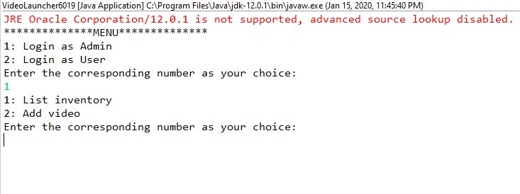

**Login as user**

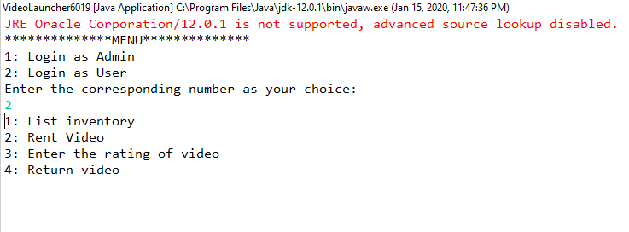

**List Inventory function**

Case-1

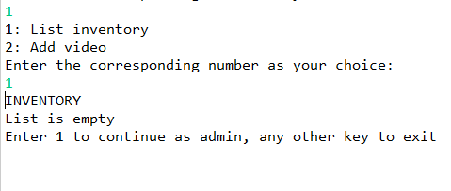

Case-2

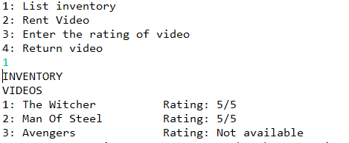

**Add video function**

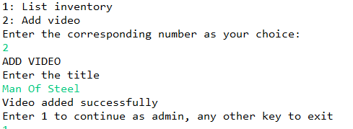

**Checkout and Rental function**

Case-1

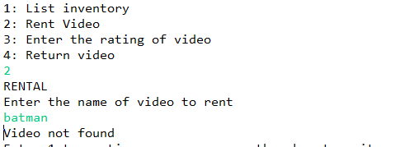

Case-2

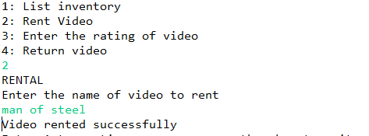

Case-3

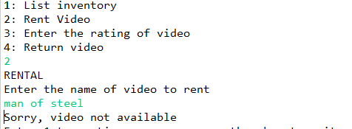

**Video Return Function**

Case-1

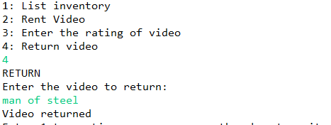

Case-2

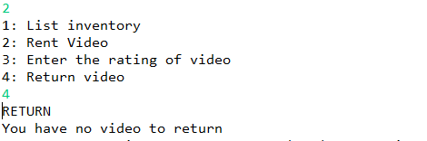

Case-3

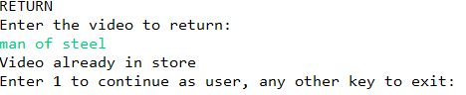

Case-3

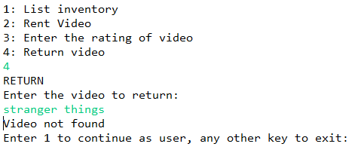

**Video Rating Function**

